**ASSIGNMENT 24.3**

**Calculate the number of employees corresponding to each skill from the table 'employee' which is loaded in the Demo.**

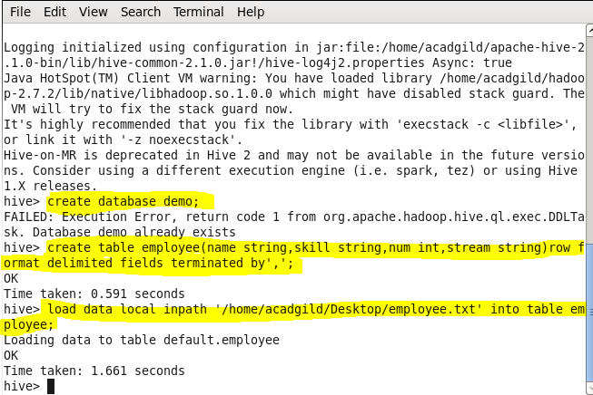

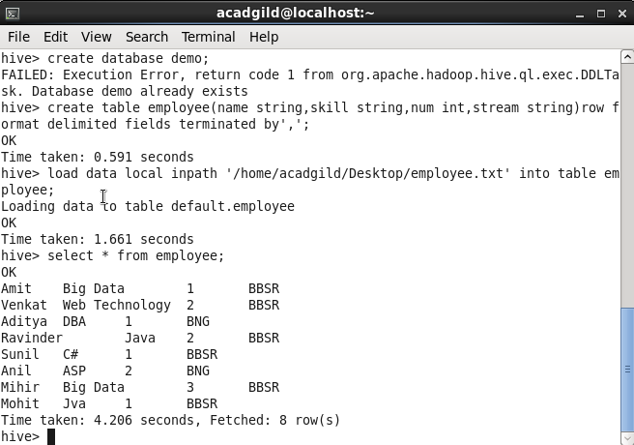

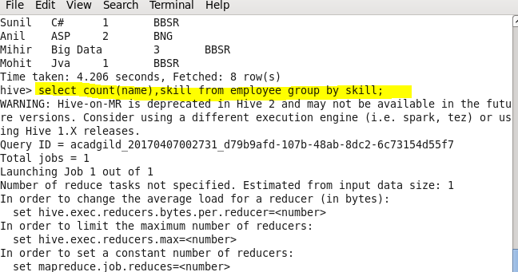

**Output**

